Junior golf iron head stainless steel material

These are golf clubs that are all the same length — custom fitted to your body.  Head weight, shaft weight, grip weight, swing weight, flex point and center of gravity are identical in all of my clubs, making the overall feel the same from one club to another.

From out experience, I’ve come to the opinion that single-length sets are superior to conventional sets.

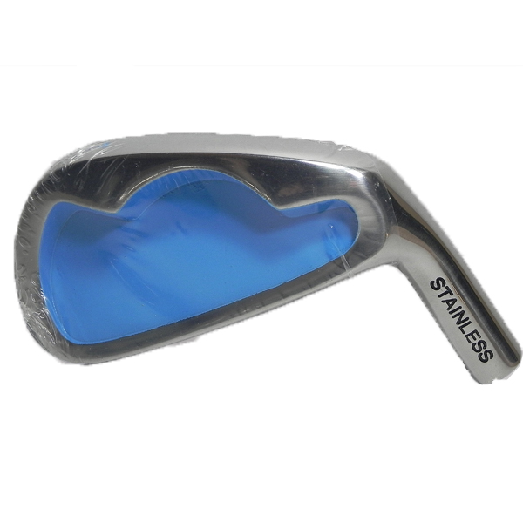

More information you can click：www.tt-golf.com