Custom color golf stand bag

1. Fleece-lined valuables pouch and removable rain hood
2. Umbrella holder and towel ring
3.Dual Density comfort strap: utilizes two materials for added comfort and stability
4.. 14-Way Organizational top
​
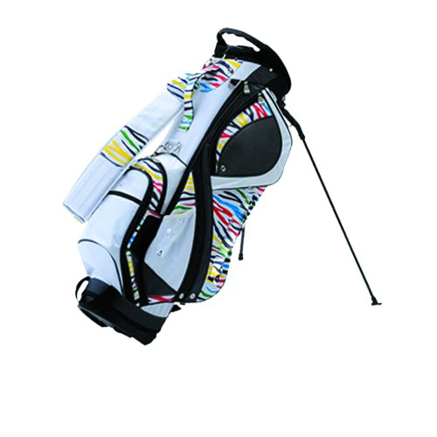
More information please click: www.tt-golf.com

